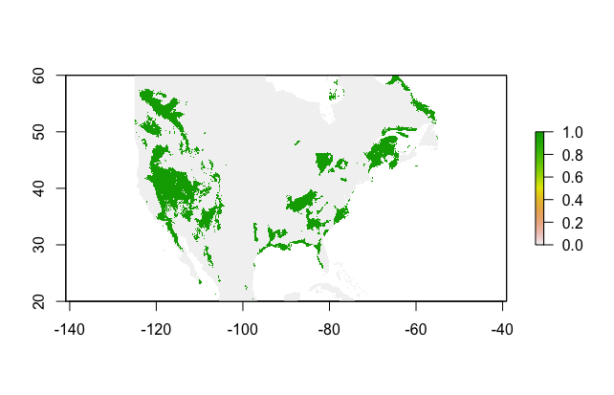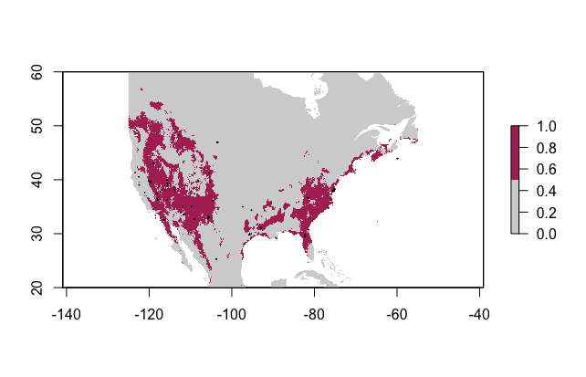The predictions map uses the predicted future climates and current data of where wild horses are found within the United States to show where horses will potentially live in the future. This is done by looking at the data for where the horses are currently found, and what type of climates are most applicable for them. This data is then used in order to determine that when the climate changes across the world, where the ideal climate is going to now be for the wild horses. Horses are pretty versatile animals, and can live in a variety of climates, since they are able to grow and shed coats based on the temperature and time of year. Because of this wild horses are found in herds across the US. They are only found in small areas due to loss of land, not due to climate. The predications map shows a wider area across the US where the horses are predicted to live with the future climate. This is because the climate is applicable to where the horses are able to live so it would predict that the herds would multiple and migrate more towards the central US. However, I do not seeing this predication being correct. This is because the human race is becoming more and more industrialized, and removing more farm land. Horses need wide areas of land in order to survive. Also, when herds of horses are taking up large areas of land that can be used for industry, they are rounded up and sold to auction so that the land can be taken over and used for humans. The map prediction is an overall good prediction for where wild horses could reside if humans stopped interfering with their lives.